Task#08-Extempore Activity

**IT IN AUTOMOBILE**

**Introduction**

Information Technology (IT) has become a transformative force in the automobile industry, enhancing vehicle performance, safety, manufacturing, and user experience. With advancements in Artificial Intelligence (AI), Internet of Things (IoT), cloud computing, and automation, IT has reshaped traditional automotive processes, making them smarter and more efficient.

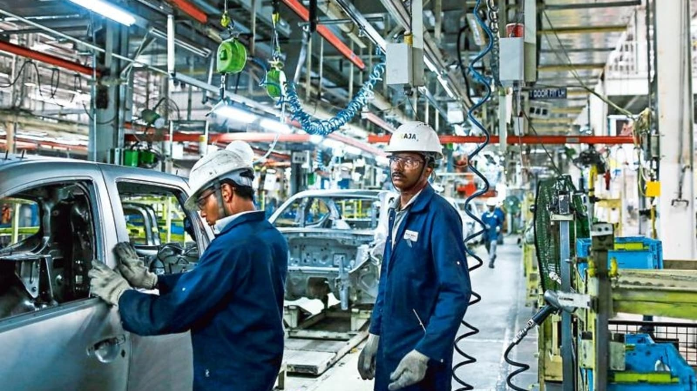**Role of IT in Automobiles**

**1. Connected Cars and IoT**

**Key IT Technologies in Automobiles**

**1. Artificial Intelligence and Machine Learning**

AI enhances vehicle decision-making, from autonomous driving to predictive maintenance. AI-powered voice assistants and driver monitoring systems improve safety and user experience.

**2. Cloud Computing and Big Data**

Cloud-based platforms store vast amounts of vehicle data, enabling predictive analytics, personalized infotainment, and fleet management solutions. Companies use big data to optimize traffic flow, improve fuel efficiency, and monitor vehicle health.

**Impact on Consumers**

Consumers benefit from IT advancements through enhanced driving experiences, increased safety, and efficient maintenance. Features like smart infotainment systems, real-time diagnostics, and remote vehicle control via mobile apps have revolutionized vehicle ownership.

**Future of IT in Automobiles**

The future of IT in automobiles is promising, with continued innovations in:

* **Electric Vehicles (EVs)**: Smart charging stations and AI-driven battery management.
* **5G Connectivity**: Faster and more reliable communication for autonomous driving.
* **Blockchain Technology**: Secure data management for vehicle history, ownership, and transactions.

**Conclusion**

IT has significantly impacted the automobile industry, driving innovation and efficiency. As technology evolves, the integration of IT in vehicles will continue to redefine transportation, making it safer, smarter, and more sustainable.

vehicle (V2V) and vehicle-to-infrastructure (V2I) communication. Features such as real-time GPS navigation, remote diagnostics, and over-the-air (OTA) software updates improve user convenience and safety.

**IT IN METRO RAIL**

**Introduction** Information Technology (IT) plays a critical role in modern metro rail systems, ensuring efficiency, safety, and convenience for passengers and operators. From ticketing systems to train control, IT solutions enhance overall operational effectiveness and customer experience

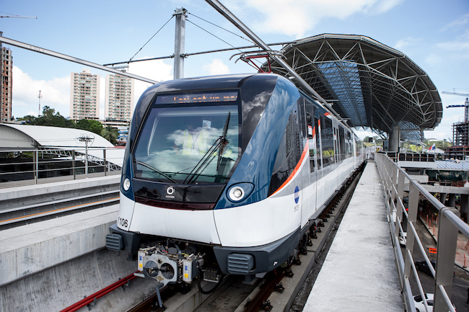**1. Automated Fare Collection (AFC) Systems** AFC systems allow passengers to enter metro stations using smart cards, mobile QR codes, or contactless payment methods. These systems reduce manual ticketing efforts, minimize fraud, and provide seamless travel experiences.

* **Smart Cards**: Stored-value cards that allow multiple rides without needing cash transactions.
* **Mobile Ticketing**: QR-based tickets generated through mobile apps for hassle-free access.
* **Online Recharge**: Digital platforms for recharging metro cards improve convenience.

**2. Passenger Information Systems (PIS)** Real-time information is essential for enhancing passenger experience. PIS provides up-to-date information through digital displays, mobile apps, and audio announcements.

* **Digital Displays**: Show train schedules, delays, and route information.
* **Mobile Applications**: Provide real-time tracking of trains and expected arrival times.
* **Automated Announcements**: Voice-based updates for passengers regarding upcoming stations and safety alerts.

**3. Train Control and Signaling Systems** Modern metro rail systems rely on advanced IT-driven train control and signaling mechanisms for safe and efficient operations.

* **Communication-Based Train Control (CBTC)**: A wireless signaling system ensuring precise train movement and reducing headways.
* **Automatic Train Operation (ATO)**: Partially or fully automated driving systems to ensure efficiency and safety.
* **Supervisory Control and Data Acquisition (SCADA)**: Monitors and controls electrical, mechanical, and operational functions in the metro network.

**4. Security and Surveillance Systems** Ensuring passenger safety is a priority for metro rail systems, and IT plays a significant role in surveillance and security management.

* **CCTV Monitoring**: Cameras placed at stations and inside trains for real-time security monitoring.
* **Biometric Access Control**: Facial recognition and fingerprint access for authorized personnel.
* **AI-Based Threat Detection**: Automated systems that identify suspicious activities and alert security teams.

**5. Enterprise Resource Planning (ERP) in Metro Rail** ERP solutions streamline internal operations, including asset management, workforce planning, and maintenance scheduling.

* **Asset Management**: Tracks metro infrastructure and rolling stock conditions to optimize maintenance.
* **Workforce Management**: Digitally manages shift schedules, attendance, and payroll systems.
* **Predictive Maintenance**: Uses IoT and AI to predict and prevent potential system failures.

**Conclusion** The integration of IT in metro rail systems has transformed urban transportation by improving safety, efficiency, and passenger satisfaction. As technology evolves, advancements such as AI, IoT, and cloud computing will further enhance metro rail operations, making them more sustainable and user-friendly.